

**BADAWAR WEB User Stories**

**PREPARED by: rADWA KARAM**

**August 18, 2018**

1. **Login Screen user story**

As a user(School admin), I want to login using my credentials, so I can start using the application.

Acceptance Criteria:

* The user can enter his user name or email.
* User email conforms to the email regex
* User password should be of 8 characters minimum length
* User email and password combination is correct
* User is automatically logged in after the first login unless forcibly logged out
* Link to the forgot password function is found
* A button to register a new account is found

**Error scenario:**

* Internet connection is lost
  + A message should be displayed banning the user from login:
  + “Connectivity Error! Please check your internet connection and try again.”
* If email value is in wrong format, an immediate error message should be displayed, “This doesn’t look like a valid email address”
* Wrong user email should display a message that it is wrong “Invalid Email or Password”
* Wrong user password should display a message that it is wrong“Invalid Email or Password”
* Unregistered user should receive a message: “Ooops, you don’t have an account yet. Please create an account now”



1. Forgot Password User Story

As a user, I want to reset my password in case I forgot it.

**Acceptance Criteria:**

* + When the user clicks on forgot password link, the user is redirected to a new screen to enter the verification code sent over the user mobile phone via SMS.
  + And there is a counter for 1 min, if it is passed without entering the verification code, Resend Code button will appear.
  + Once the user clicks on resend code button, a new verification code will be sent to the user via SMS.
  + And there is “Next” button exist, when the user clicks on it, a new screen will appeared to enter his new password and confirm password.
  + The new password must match with confirm new password.
  + Then the user clicks on “Save” button, the new password will be saved in the database. And then the user is redirected to the login screen to enter his mail and his new password to log in.

**Error Criteria:**

* Code entered is not correct
  + Error message must be displayed to ban the user from proceeding: “The code is incorrect. Please enter the right one.”
* New password length is not 8 characters long
  + If, while writing the password, the length is too short, then an immediate error message should be displayed.
* Confirm password value is not the same as the password value
  + Error message must be displayed to ban the user from proceeding: “Password doesn’t match!!”
* Confirm password value is not 8 characters long
  + If, while writing the password, the length is too short, then an immediate error message should be displayed.
* Internet connection is lost
* A message should be displayed banning the user from proceeding and stating the following: “Connectivity Error! Please check your internet connection and try again.”





1. Registration User Story

As a school owner, I want to register a new school account, so I can add my school(s) to be managed in the system.

**Acceptance Criteria:**

* When the user clicks on “Register Now” button, a new section is appeared asked the user to enter the schhol name he want to register.
* The new section consists of :
* School name… Text Field.. Search Auto Complete.
* Next Button.
* When the user clicks on “Next ” button, there is 3 cases we will go through:

1. If the school name exists in the database and managed by a school admin, a message is displayed “The account is already registered for this school, if you would like to report a problem, Please contact us at [www.Badawar.com](http://www.Badawar.com)”
2. If the school name exists in the data base and managed by the system admin, then the user is redirected to enter his contact information only.

* The contact information :
* Name.. text field.
* Mobile.. text field.
* Email…text field.
* Title…text field.

1. If the school desnt exists in the database, so he will go through the normal registration process by redirect the user to the first registrstion screen to enter the school data.

* The registration is only availble to the user type no. 3 whoes school don’t exist in the database .

**Error Criteria:**

* Internet connection is lost
* A message should be displayed banning the user from proceeding and stating the following: “Connectivity Error! Please check your internet connection and try again.”
* If the user didn’t enter the school name, a message will be displayed to the user “Please enter the school name”



**4.** School Details Registration screen

As a user, I want to enter the school details, so that it will be registered on the system

**Acceptnce Criteria:**

* English School name* … Text Field.
* Arabic School name* … Text Field.
* English short name… Text Field.
* **NB: Make a verfication that when theuser write english name, allow to write only the english charcaters and don’t allow to write arabic characters and vice versa.**
* User first name*…Text Field
* Last Name*…. Text Field.
* Email*…. Text Field, Email must conform to the email regex.
* Mobile*… Text Field.
* Password*. Text Field.
  + Accepts alphapitical, special characters and numerical entries
  + User password should be of 8 characters minimum length
  + Does not allow the entry of the same character more than the half of the password length
* Confirm Password*… Text Field, Should match the password field.
* Next Button, when the user clicks on it,all the entered data will be saved and the user will redirect to another screen to complete the registration process.

**Error Criteria:**

* If the school name is already exists in the database, an error message will be displayed “This school name is already exists, Please contact us @ [www.Badawar.com](http://www.Badawar.com)”
* If the English School Name or Arabic School name is not entered
  + Error message must be displayed, “ School Name cannot empty!”
* Email field is empty
  + Error message must be displayed, “Email cannot empty!”
* Email value doesn’t conform to the email regex
  + Error message must be displayed, “Warning! Invalid email format..”
* Email is registered before
  + Error message must be displayed, “Warning! This email is already registered, if you forgot your password, click forgot password”
* Password length is less than 8 characters
  + Error message must be displayed, “Password length should be of 8 characters long at least.”
* Confirm password field value doesn’t match the password field
  + Error message must be displayed, “Password doesn’t match!”
* Confirm password field value length is not 8 characters long
  + Error message must be displayed, instantly while typing, “Confirm Password length should be of 8 characters long at least.”
* Internet connection is lost
  + A message should be displayed banning the user from registration and stating the following: “Connectivity Error! Please check your internet connection and try again.”

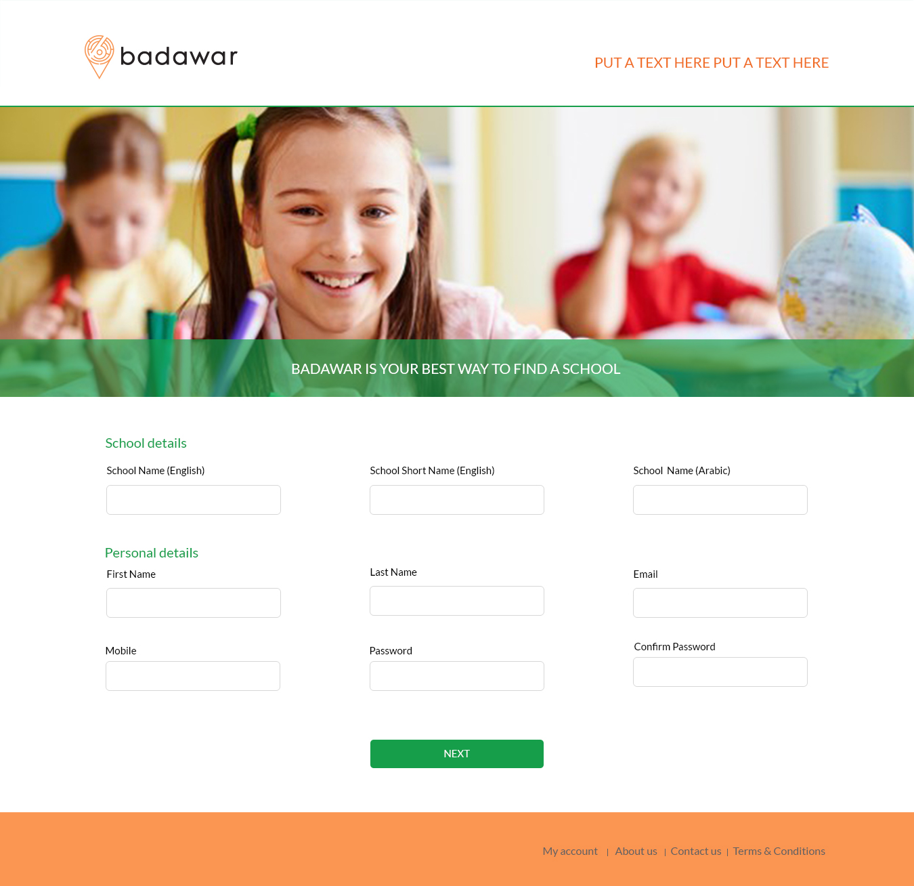

**5.** Branch Details Registration Screen

As a user , I want to enter the branch details, so that it will be added to the school details to be registered.

**Acceptance Criteria:**

* English Branch Name*…Text Field.
* English Branch short name.. Text field.
* Arabic Branch name*.. Text Field.
* **NB: Make a verfication that when theuser write english name, allow to write only the english charcaters and don’t allow to write arabic characters and vice versa.**
* City*..Drop down menu with all cities.
* Zone*… Drop down menu display all zones in the selected city.
* English Address*… Text field.
* Arabic Address*… Text Field.
* Email*… Text Field.
* Phone*…Text Field.
* IB Certified… CheckBox
* Shadow Teacher.. CheckBox.
* Is Main… CheckBox..If it is checked then it is the main branch of the school.
* Facebook…TextField
* Website..TextField
* AddPOI…TextField…the user can enter his location directly or he can click on “my location” link. Then navigate his location.
* Add Facility, there is + sign beside it to add new facilty from.
* Add Certificate , there is + sign beside it to add new certificate from.
* Add contact, there is + sign beside it to add new contact from.
* Add Gallery, there is + sign beside it to add new image from.
* Add Fees, there is + sign beside it to add new academic details from.
* Register button.. when the user clicks on it all the enetered data saved in the database, and a pop up message appeared “Your account will be activated after the admin approval”

**Error Criteria:**

* Internet connection is lost
  + A message should be displayed banning the user from registration and stating the following: “Connectivity Error! Please check your internet connection and try again.”
* Branch name english or Arabic field is empty
  + Error message must be displayed, “Branch name cannot empty!”
* City field is empty
  + Error message must be displayed, “City cannot empty!”
* Zone field is empty
  + Error message must be displayed, “Zone cannot empty!”
* Address field is empty
  + Error message must be displayed, “Address cannot empty!”
* Email field is empty
  + Error message must be displayed, “Email cannot empty!”
* Phone field is empty
  + Error message must be displayed, “Phone cannot empty!”

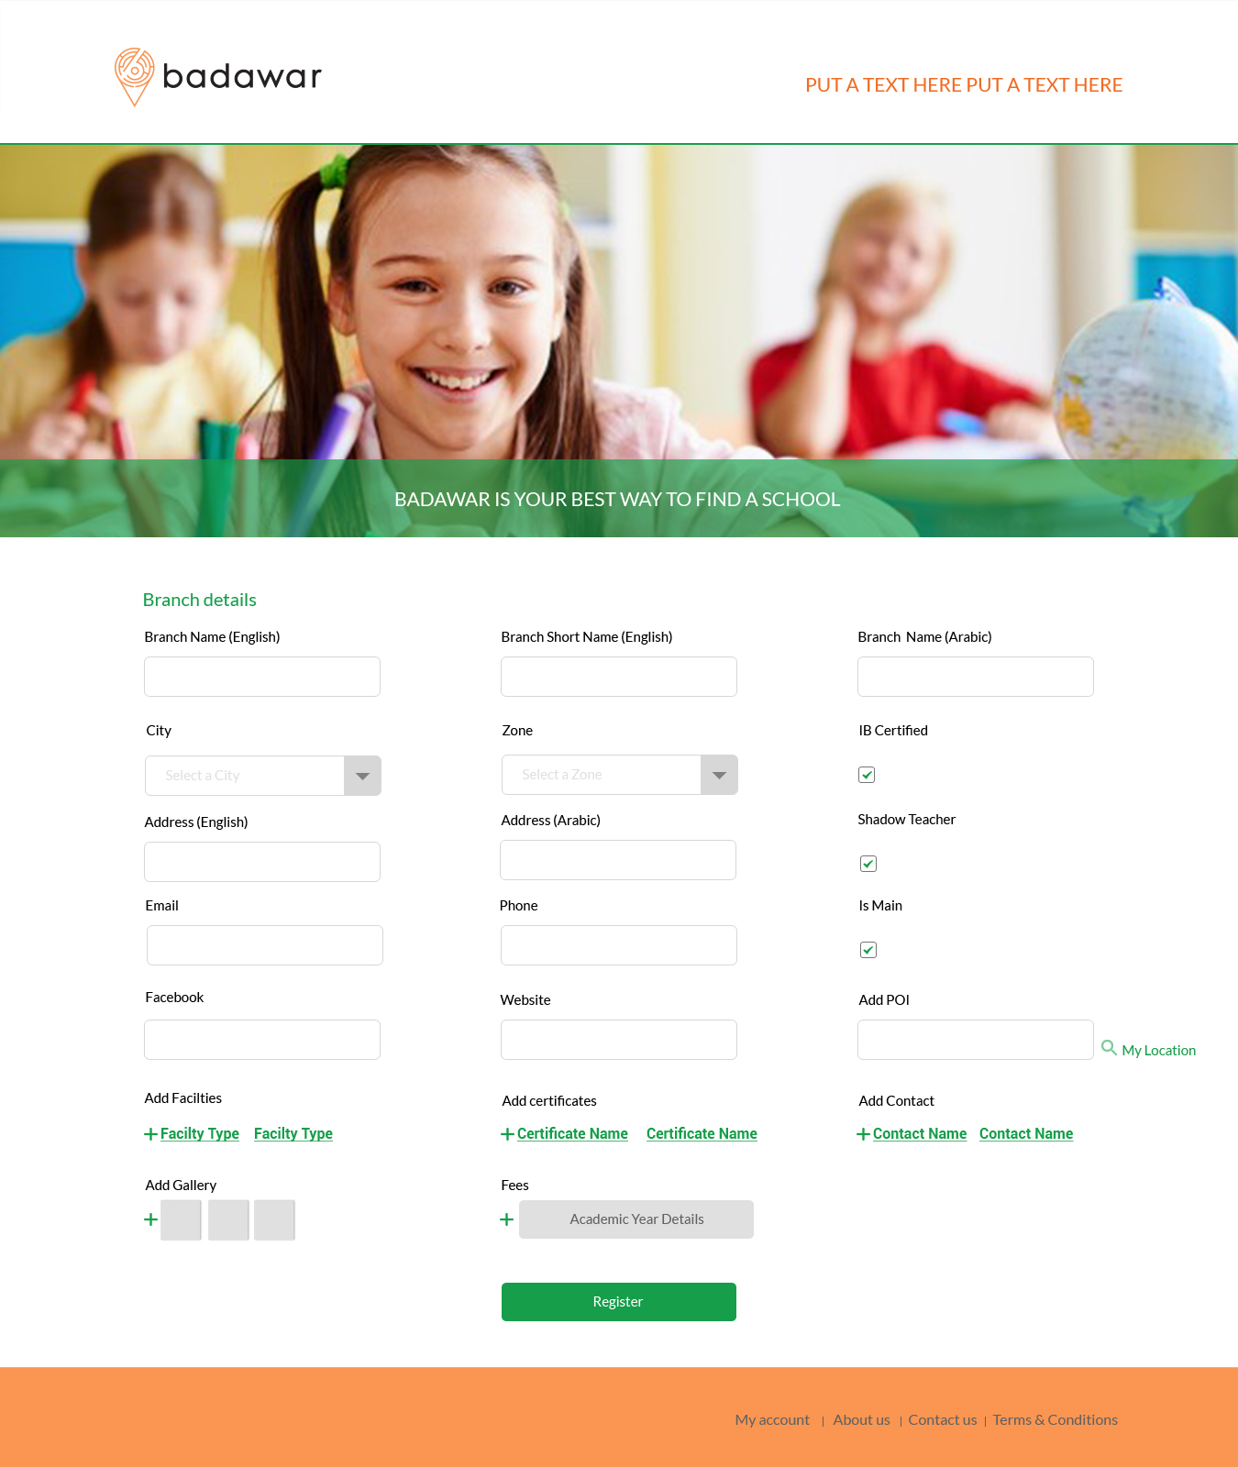

6. Add Facility User Story

As a user, I want to add the existing facilty in the registered school.

**Acceptance Criteria:**

* When the user want to add a new facility related to the school, he will clicks on + Sign beside Add facility in the branch details registration screen.
* When the user clicks on + sign, a floating page will be opened.
* The user will choose the facilty type from the drop down list. These facility type is saved in the database.
* The user will upload images related to the choosen facility type through + sign in the floating page.
* Any uploaded image will be displayed in the floating page and the user can upload another image for the same facility type.
* There is setting icon on each image, it will appear when the user roll over the image.
* The user can delete or make this image as a cover photo to this facility type from the setting icon.
* The user can close the floating page by pressing the x sign in the upper right corner in the floating page without saving the data. Then a pop up message appeared asking the user “Are you sure you want to exit?” if he press yes, the entered data will be cleared and the floating page will disappear. But if he press no,nothing will change.
* When the user upload all the images for this facility type, he will press on ADD button . And then the added facility type will be saved in the database, and displayed on the registration screen as a link.
* The user can delete this facility from the small x beside the link.

**Error Criteria:**

* Internet connection is lost
  + A message should be displayed banning the user from registration and stating the following: “Connectivity Error! Please check your internet connection and try again.”

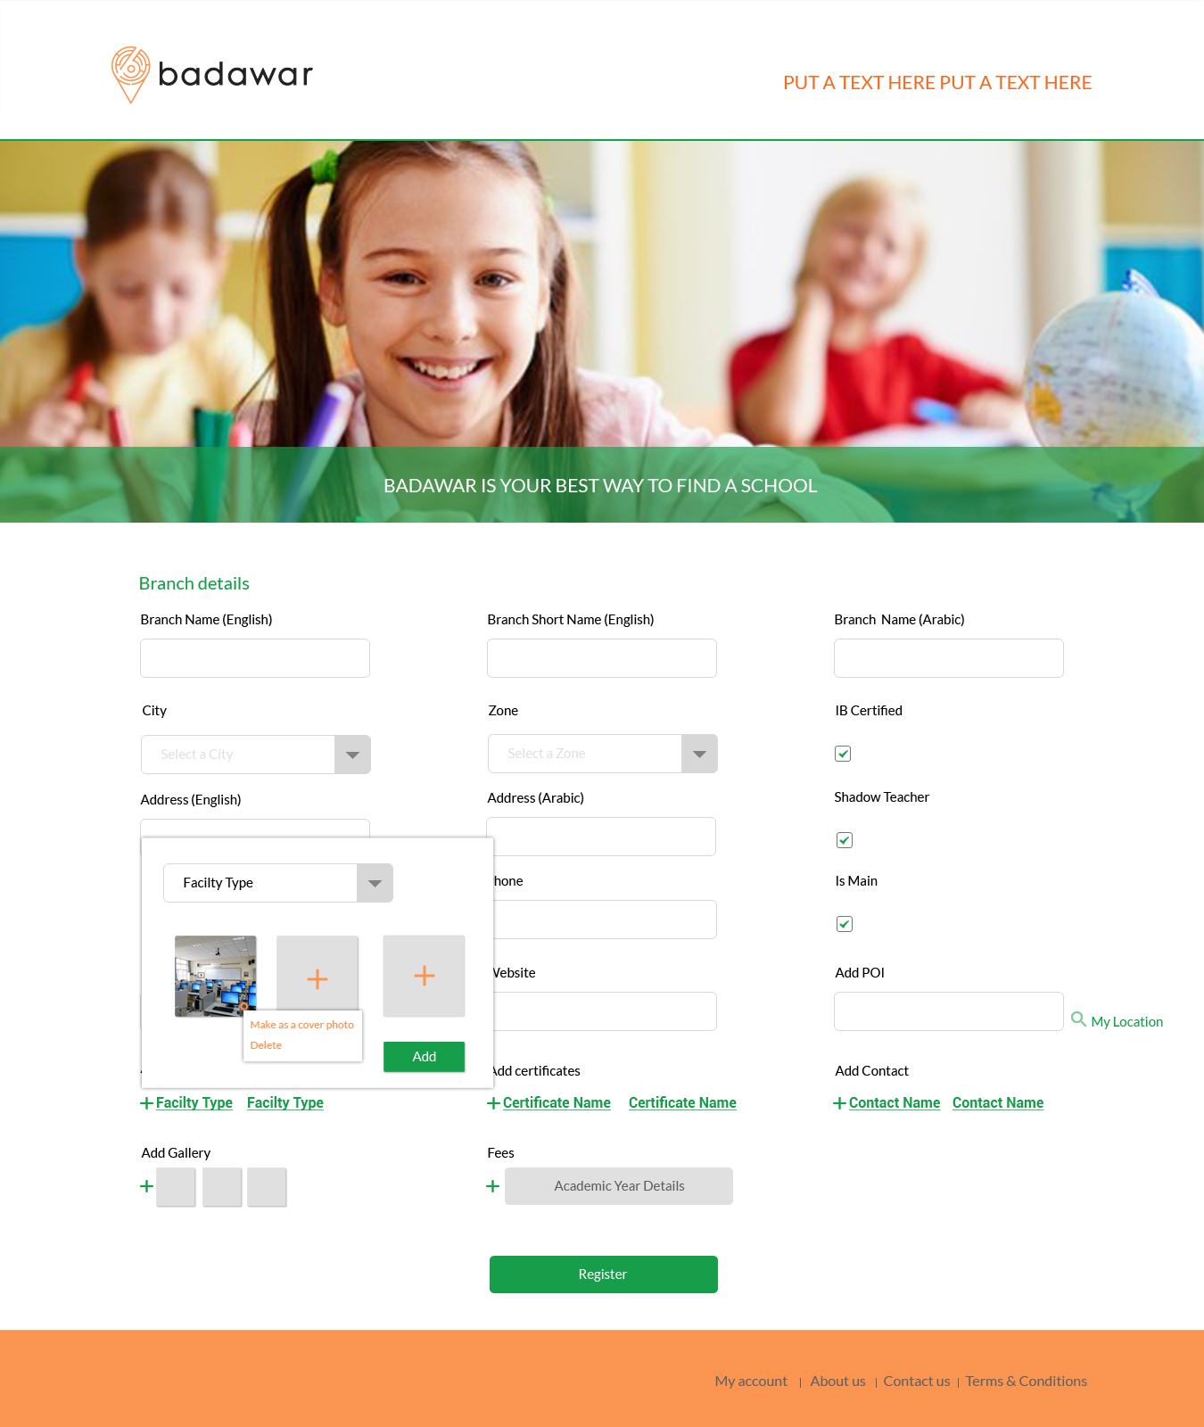

**7. Add Certificate User Story**

As a user, I want to add the currilculm certificate of the school, so that the parent will trust the school.

Acceptance Criteria:

* When the user want to add a new certificate related to the school, he will clicks on + Sign beside Add certificate in the branch details registration screen.
* When the user clicks on + sign, a floating page will be opened.
* The user will choose the certificate type from the drop down list. These certificate type is saved in the database.
* The user will upload image related to the choosen certificate type through + sign in the floating page.
* There is only one image for each certificate type.
* The user can add many certificate type in the same floating page.
* The user can delete the uploaded image in the floating page, by pressing on the small x on the image.
* The user can close the floating page by pressing the x sign in the upper right corner in the floating page without saving the data. Then a pop up message appeared asking the user “Are you sure you want to exit?” if he press yes, the entered data will be cleared and the floating page will disappear. But if he press no,nothing will change.
* When the user finish all the certificate types, he will clicks on Add button to be saved in the database and added on the registration screen in the form of link.
* The user can delete this facility from the small x beside the link.

**Error Criteria:**

* Internet connection is lost
  + A message should be displayed banning the user from registration and stating the following: “Connectivity Error! Please check your internet connection and try again.”

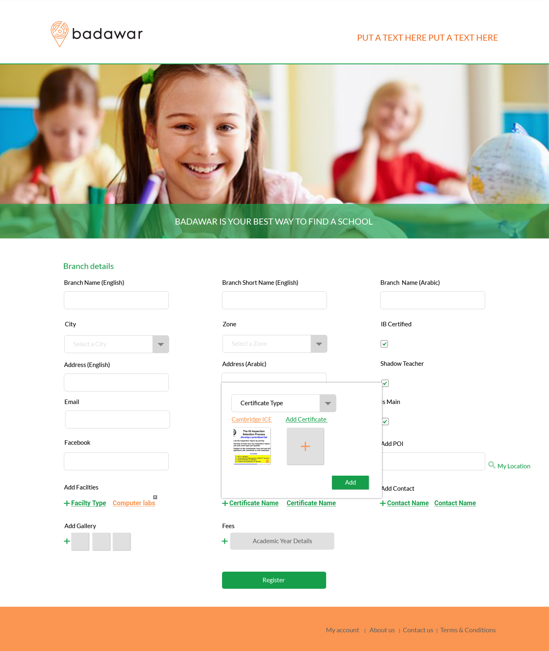

8. **Add contact User story**

As a user, I want to add contact to the registered school, so that it can be reached easily.

**Acceptance Criteria:**

* When the user want to add a new contact to the school, he will clicks on + sign beside add contact in the add branch registration screen.
* When he clicks on + sign, a floating page will appear to enter the contact details.
* The floating page consists of :
* The contact Photo, the user can upload the photo by clicking on the upload sign on the image.
* Name.. Text Field
* Mobile.. Text Field
* Email… Text Field
* Tiltle.. Text Field
* Add Button.. When the user enter the contact details, he clicks on Add button to save all the entered data in the database and it will be displayed in the registartion screen as alink.
* The user can close the floating page by pressing the x sign in the upper right corner in the floating page without saving the data. Then a pop up message appeared asking the user “Are you sure you want to exit?” if he press yes, the entered data will be cleared and the floating page will disappear. But if he press no,nothing will change.
* The user can delete this contact from the registartion screen.

**Error Criteria:**

* Internet connection is lost
  + A message should be displayed banning the user from registration and stating the following: “Connectivity Error! Please check your internet connection and try again.”

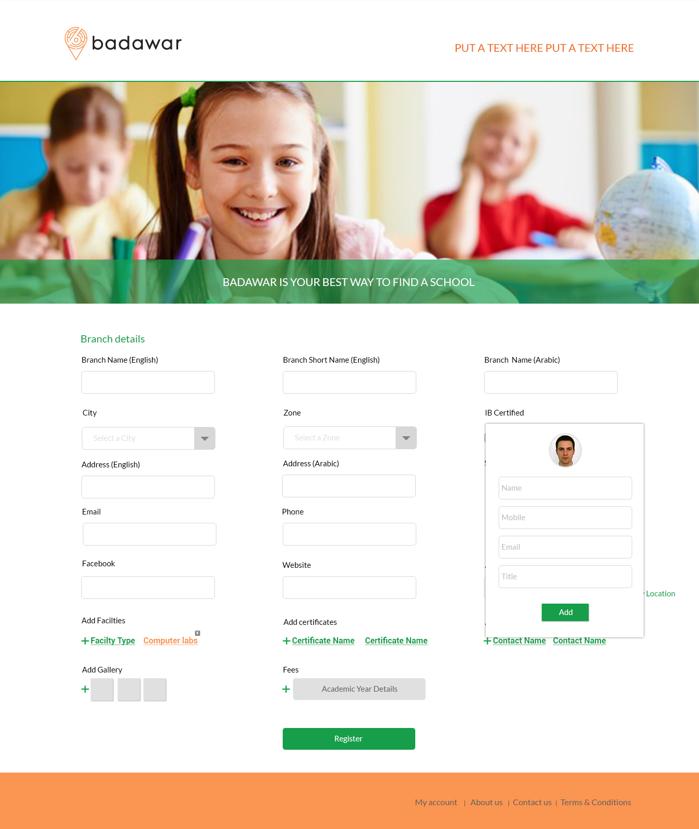

**9. Add Gallery User Story**

As a user, I want to add images to the school.

**Acceptance Criteria:**

* When the user want to make a gallery to the school, he clicks on the + sign beside Add gallery in the registration screen.
* When the user clicks on + sign, a floating page will be opened.
* The user will upload images through + sign in the floating page.
* Any uploaded image will be displayed in the floating page and the user can upload another image for the school.
* There is setting icon on each image, it will appear when the user roll over the image.
* The user can delete or make this image as a cover photo to the school from the setting icon.
* The user can close the floating page by pressing the x sign in the upper right corner in the floating page without saving the data. Then a pop up message appeared asking the user “Are you sure you want to exit?” if he press yes, the entered data will be cleared and the floating page will disappear. But if he press no,nothing will change.
* When the user upload all the images, he will press on ADD button . And then these images will be saved in the database, and displayed on the registration screen as a small images.
* The user can click on the image on the registration screen to view it and can delete it.

**Error Criteria:**

* Internet connection is lost
  + A message should be displayed banning the user from registration and stating the following: “Connectivity Error! Please check your internet connection and try again.”

